**PROJECT REPORT ON “AIRPLANE RESERVATION SYSTEM”**

**B.SC.(HONOURS) SEMESTER-VI EXAMINATION, 2023 (UNDER CBCS)**

**THE UNIVERSITY OF CALCUTTA**



**PROJECT SUBMITTED BY:**

**SAMADRITA MUKHERJEE 203224-11-0072**

**ANTARITA DAS 203224-11-0070**

**SASWATI MUKHERJEE 203224-11-0065**

**SAHELI MALAKAR 203224-11-0106**

**PROJECT GUIDE:**

**Prof. PRITAM GHOSH, LECTURER IN COMPUTER SCIENCE,**

**DEPARTMENT AT SETH ANANDARAM JAIPURIA COLLEGE**

**CERTIFICATE**

This is to certify that the project entitled ‘AIRPLANE RESERVATION SYSTEM’, has been submitted by SAMADRITA MUKHERJEE (Roll No: 203224-11-0072, Registration No: 224-1211-0681-20 of 2020-2023), ANTARITA DAS (Roll No:203224-11-0070, Registration No: 224-1211-0676-20 of 2020-2023), SASWATI MUKHERJEE (Roll No:203224-11-0065, Registration No:224-1211-0658-20 of 2020-2023) and SAHELI MALAKAR (Roll No:203224-11-0106, Registration No: 224-1212-0664-20 of 2020-2023) in partial fulfilment of requirements for the degree of Bachelor of Science (B.SC.) in Computer Science, from the University of Calcutta, 2023, and that it has been prepared according to the rules of University of Calcutta.

Prof. Pritam Ghosh Prof. Chaitali Patra

**Project Guide Head of Department**

Department of Computer Science Department of Computer Science

(Seth Anandram Jaipuria College, CU) (Seth Anandram Jaipuria College, CU)

**ACKNOWLEDGEMENT**

We had a great experience working on this project and we got to learn a variety of new skills through this project. However, it would not have been possible without the kind support and help of many individuals. We would like to extend our sincere thanks to all of them. We are highly indebted to the teachers for their guidance and constant supervision as well as providing necessary information regarding the project and also for their support in completing the project. I would also like to thank Prof. Chaitali Patra, Head of the Department of Computer Science, for providing a good environment and facilities to work on this project.

I regret any inadvertent omissions.

**DATED:**

SAMADRITA MUKHERJEE ANTARITA DAS

ROLL NO.: 203224-11-0072 ROLL NO.: 203224-11-0070

SASWATI MUKHERJEE SAHELI MALAKAR

ROLL NO.: 203224-11-0065 ROLL NO.: 203224-11-0106

**PROJECT TITLE:**

**FIRSTFLY AIRPLANE RESERVATION SYSTEM**

**INDEX**

|  |  |
| --- | --- |
| **TOPIC** | **PAGE NUMBER** |
| **ABSTRACT** | **1** |
| **INRODUCTION**   * **PROJECT OVERVIEW** * **DOMAIN DESCRIPTION** * **MOTIVATION** * **SCOPE OF THE WORK** | **2-4** |
| **SYSTEM SPECIFICATIONS** | **5** |
| **BACKGROUND AND REVIEW RELATED WORKS** | **6** |
| **METHODOLOGY**   * **USER PANEL & ADMIN PANEL** * **ALGORTIHM DESCRIPTION** | **7-10** |
| **USE CASE DIAGRAM** | **11** |
| **ER DIAGRAM** | **12** |
| **DATA FLOW DIAGRAM** | **13-16** |
| **SCHEMA DEFINITION** | **17-22** |
| **IMPLEMENTATION** | **23-24** |
| **RESULTS AND DISCUSSION** | **25-35** |
| **FUTURE SCOPE** | **36** |
| **REFERENCES** | **37** |
| **CONCLUSION** | **38** |

* **ABSTRACT**

The Airplane Reservation System is a web-based application designed to streamline and simplify the process of flight booking and management. This system aims to provide users with a user-friendly interface, efficient search functionality, secure payment processing, and comprehensive flight information. It caters to both individual travelers and travel agencies, offering a seamless reservation experience.

The system incorporates modules such as user registration and login, flight search and booking, seat selection, payment processing, cancellation, and administration. Users can search for flights based on their preferred criteria such as destination, date, and seat class. The system presents a list of available flights, allowing users to select their desired flight and proceed with seat selection and finally payment.

The Airplane Reservation System also includes an administration module, granting authorized control over flight schedules, user management, pricing, and other administrative tasks. The system adheres to data privacy regulations, ensuring the protection of customer information.

With the Airplane Reservation System, users can conveniently manage their flight reservations, view booking details, and access customer support services. The system enhances the overall travel experience, providing users with a reliable and efficient platform for flight bookings while offering administrators the tools to manage flights, monitor bookings, and maintain data integrity.

In summary, the Airplane Reservation System aims to revolutionize the way flights are booked and managed, offering a user-friendly interface, comprehensive features, and robust security. By leveraging technology and automation, this system seeks to provide a seamless and hassle-free flight booking experience.

* **INTRODUCTION**
* **PROJECT OVERVIEW**

Airplane reservation system contains the details about the flights schedules and its fare prices, passenger reservation and ticket records.

* **DOMAIN DESCRIPTION**

Airplane reservation system will hold the flight schedules and, passenger reservations and ticket records. It saves time as it allows online procedure as users no longer have to wait in a queue to book flights. It is automatically generated by the server. Admin is the main authority who can do addition, deletion and modifications of flights if required.

The database connectivity is planned using the “SQL Connection” methodology. The standards of security and data protective mechanism have been given a big choice for proper usage. The application takes care of different modules and their associated reports, which are produced as per the applicable strategies and standards that are put forwarded by the administrative staff.

This project also covers various features like online registration of the users, modifying the details of the website by the management staff or administrator of the website, by adding, deleting or modifying the booking details, flights information. In general, this website would be designed to perform like any other airline ticketing websites available online.

* **MOTIVATION**

There are several motivations for undertaking this project:

* Addressing a Real-World Need: The airline industry is a significant sector of global transportation, and an Airplane Reservation System addresses the real-world need for efficient and user-friendly flight booking and management. By developing such a system, we contributed to improve the travel experience for individuals and organizations by providing a streamlined and convenient platform for booking flights.
* Enhancing Efficiency: Traditional methods of flight booking and management can be time-consuming and prone to errors. An Airplane Reservation System automates and streamlines the process, reducing manual work and increasing efficiency. This can save time for both travelers and airline staff, resulting in a smoother experience for all parties involved.
* Improved Customer Experience: A well-designed Airplane Reservation System can significantly enhance the customer experience. By providing a user-friendly interface, easy navigation, comprehensive flight information, and secure payment options, the system can make the flight booking process convenient and hassle-free for users.
* Technological Advancements: Developing an Airplane Reservation System allowed us to leverage and showcase the technical skills and expertise. We utilized modern web technologies, programming languages, to build a robust and scalable system. This project served as a showcase of our abilities and helped to expand our knowledge in web development, database management, security, and user experience design.

In summary by developing such a system, we have made a positive impact on the travel industry and gain valuable skills and experiences along the way.

* **SCOPE OF THE WORK**

The scope of our project Airplane Reservation System project may include the following components:

* User Registration and Authentication: The system allows users to create accounts and authenticate themselves securely. This includes implementing user verification, password management, and account activation mechanisms.
* Flight Search and Selection: Users can search for flights based on various criteria such as origin, destination, date, and seat class. The system retrieves and displays relevant flight options, including details such as airlines, departure/arrival times, and the respective fares.
* Seat Selection: The system provides an interactive seating map that allows users to select their preferred seat and allows users to view their seat selections.
* Booking and Reservation Management: Users can make flight bookings, including selecting flights, entering passenger details, and confirming the reservation. The system generates unique booking reference numbers.
* Payment Processing: The system integrates secure payment gateways to facilitate online payment transactions.
* Ticket Generation: Once a booking is confirmed and payment is processed, the system generates electronic tickets. These tickets contain essential information such as flight details, passenger names, seat numbers, and fare breakdowns.
* Reservation Cancellation: The system allows users to cancel their flight reservations within specified rules and conditions.
* Administration and Management: The system includes an administration module that allows authorized personnel to manage flight schedules, monitor bookings, and feedbacks given by users. Administrators can view and edit flight information, manage fares, and perform administrative tasks efficiently.
* **SYSTEM SPECIFICATIONS**

System requirement give an idea about what are the necessary things that are needed for the proposed system, which plays a very important role in the development of any system. It deals with what are hardware components that are needed for the system, application software that is required for the development of the system and the functional requirement of the system. Frontend tools helps to visualize the system, while backend helps in activities which are not visible to the end user.

* **HARDWARE SPECIFICATION**
* Intel processor.
* RAM 4GB and above.
* HDD 20 GB Hard Disk Space and above.
* **SOFTWARE SPECIFICATION**
* WINDOWS OS (developed in windows 10).
* XAMPP Server for Windows (Apache).
* Database MySQL for Backend.
* Front End Tools HTML,PHP, CSS, JAVASCRIPT.
* **BACKGROUND AND REVIEW RELATED WORK**

After acquiring knowledge of the necessary programming languages and understanding the technical aspects of web development, we conducted in-depth research on the current landscape of public services. Considering the ongoing pandemic situation, the demand for safe and contactless travel services has surged. As a result, air travel has become increasingly popular due to its time efficiency and the potential for a reduced risk of transmission.

To gain insights into industry best practices and user expectations, we thoroughly analyzed several prominent air travel websites such as 'IndiGo'. By exploring these websites, we examined their user interfaces, booking processes, flight search functionalities, seat selection options, and overall user experience. This analysis helped us to identify successful features, understand user preferences, and determine areas where we could introduce innovations to enhance the reservation process.

We also studied the feedback and reviews from users of existing air travel websites to gain valuable insights into their experiences. This feedback analysis provided us with a better understanding of common issues faced by users, enabling us to address them in our website design and functionality.

By combining our research findings, industry knowledge, and innovative ideas, we aimed to develop a robust and user-friendly website that provides a seamless and secure air travel booking experience.

* **METHODOLOGY**

There are two parts of our project one is the admin panel and user panel. Each panel has been divided into several modules.

* **User Panel:**

This zone is basically for customers/clients. The user directly interacts with the system and perform the following activities:

### Registration and Login:

The Login module first requires a user registration feature that allows new users to create an account within the system. Users provide their personal data during the registration process. The module ensures that the provided information is valid and unique to avoid duplication.

Once registered, users can log into the system using their credentials, typically a username/email and a password. The Login module verifies the user's identity by checking the entered credentials against the stored user database.

### Flight Booking and Cancellation:

The Flight Booking module provides users with a search interface where they can input their travel preferences such as departure and arrival locations, travel dates, and any other relevant criteria. The module then displays a list of flights that meet the specified criteria

Once users have selected their desired flight, the module collects necessary passenger information, such as name, gender and type of passenger. Next the users can select their preferred seats. The module provides a visual representation of the aircraft's seating layout, allowing users to choose seats based on their preferences.

The Flight Booking module integrates with secure payment gateways to enable users to make secure online transactions for their flight bookings. In our case the payment process is kept dummy for security purposes. Once the payment is successfully processed, the Flight Booking module generates electronic tickets or booking confirmations for the users. These tickets contain essential information such as flight details, passenger names, seat assignments, and booking references.

Customer can also cancel their flight booking using their booking id.

### About us/Feedback:

The "About Us" page typically provides information about the website, and its purpose. We have also provided a feedback form in our About us page that allows users to provide feedback on their experience with the system and its services. This module facilitates communication between users and the system operators, enabling users to share their opinions, suggestions, and concerns.

### Password Recovery:

The Password Recovery module includes a feature that enables users to initiate a password reset request. This can be done through a "Forgot Password" link or button on the login page. When clicked, users are prompted to enter the verification code they had received after successful registration process. After providing verification code the user can reset their password.

* **Admin Panel:**

This module is mainly designed for administrative activities. System will check the admin password for authentication. After the verification for authorization the admin can be able to proceed next.

### Flight update:

The admin is in charge of this page. The admin module allows administrators to manage flight schedules within the system. They can update existing flight schedules, modify departure and arrival times and adjust flight durations.

### Flight addition and deletion:

Administrators can add new flights to the system. They can enter flight details such as flight id flight name arrival and departure time and duration. Similarly, they can delete flights that have been discontinued or are no longer operational.

### Customer feedback:

The admin can get to see the feedback provided by the customers and incorporate new changes or updates based on the feedback they have received from users if they feel necessary.

### Customer details:

The admin module in the Airplane Reservation System includes afunctionality that allows administrators to view ticket details of customers and also passenger details. This feature enables administrators to access and review the specific details of a customer's flight reservation.

* **Algorithm Description:**

The algorithm description outlines the core functionalities and processes involved in the Airplane Reservation System project. It provides a high-level overview of how the system handles user registration, flight search, seat selection, payment processing, administrator functions.

**Steps followed by user to book flight:**

* User Registration followed by user Login
* User enters search criteria (origin, destination, date, seat class preference) to search for flight
* System presents the search results to the user and user selects a flight from the search results for booking a flight.
* Users enters passenger details and select seats
* Finally user initiates payment for the reserved flight.
* After successful payment ticket is generated and can be downloaded by the user

The user also has provisions for cancelling their flight booking and also can provide feedback on their experience on using the website.

**Steps followed by admin:**

* Admin can log in to access administrative features such as:
* Flight Schedule Update
* Flight Addition or Deletion
* View passenger ticket details, passenger details and passenger feedback details
* **USE CASE DIAGRAM**

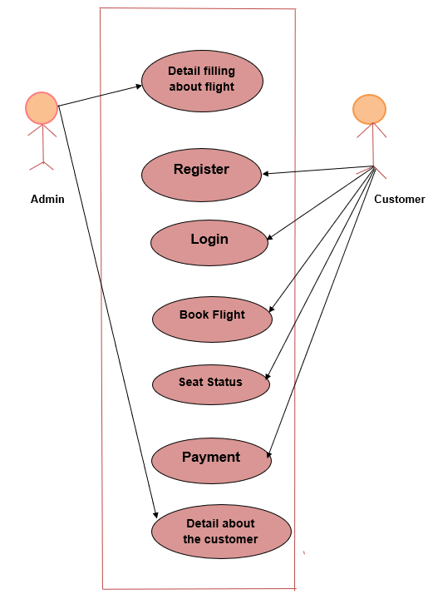A use case diagram is used to represent the dynamic behavior of a system. It encapsulates the system's functionality by incorporating use cases, actors, and their relationships. It models the tasks, services, and functions required by a system/subsystem of an application. It depicts the high-level functionality of a system and also tells how the user handles a system.

* **ER DIAGRAM**

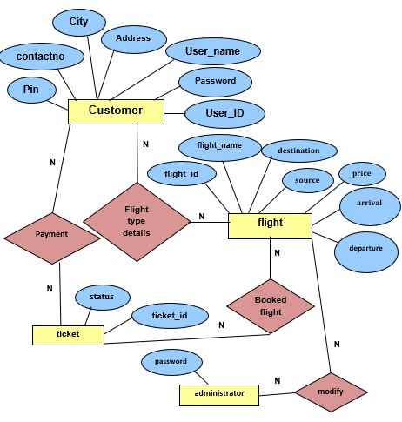ER model stands for an Entity-Relationship model. It is a high-level data model. This model is used to define the data elements and relationship for a specified system. It develops a conceptual design for the database. It also develops a very simple and easy to design view of data. In ER modeling, the database structure is portrayed as a diagram called an entity-relationship diagram.

* **DATA FLOW DIAGRAM**

DFD stands for Data Flow Diagram. It is a graphical representation used to depict the flow of data within a system or process. DFDs are commonly used in software engineering and systems analysis to visualize the inputs, outputs, processes, and data storage involved in a system.

Four simple symbols are used to complete a DFD. These are given below:

**PROCESS EXTERNAL**

**ENTITY**

**DATA FLOW DATA STORE**

* **USER PANEL:**

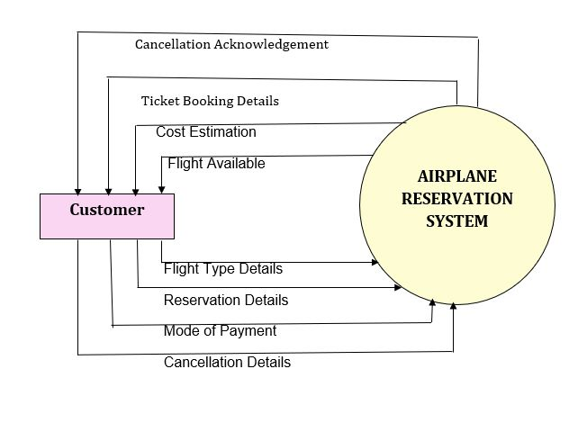**LEVEL-0 / Context Diagram:**

**LEVEL-1 DFD:**

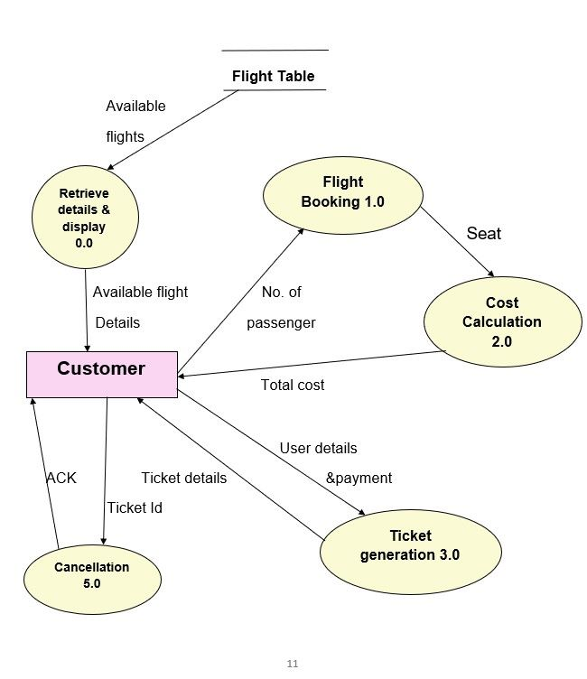

**LEVEL-2 DFD:**

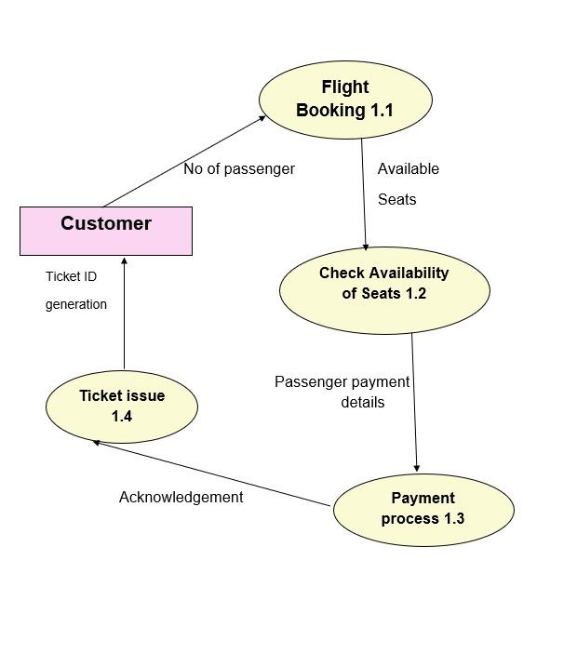

* **ADMIN PANEL:**

**LEVEL-0/ CONTEXT DIAGRAM:**

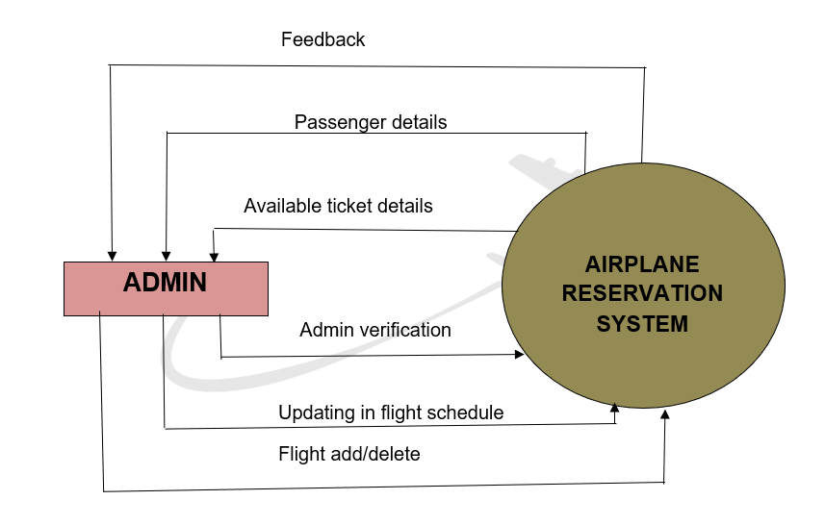

**LEVEL-1 DFD:**

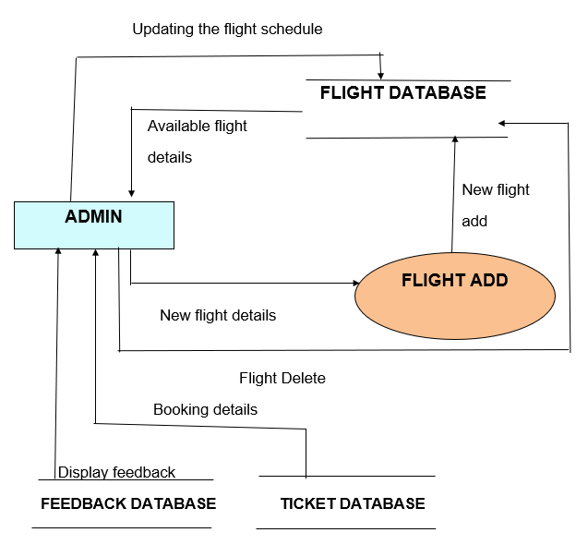

* **SCHEMA DEFINITION/DATA DICTIONARY:**
* **Data Dictionary:**

1. **Customer Table:**

|  |  |  |
| --- | --- | --- |
| **Field Name** | **Data Type** | **Description** |
| user­_ID | Varchar (30) | Not Null |
| user_name | Varchar (30) | Not Null |
| address | Varchar (300) | Not Null |
| City | Varchar (30) | Not Null |
| Pin | Int (10) | Not Null |
| contactno | Varchar (20) | Not Null |
| password | Varchar (20) | Not Null |
| code | Mediumint (10) | Not Null |
| status | Varchar (20) | Not Null |

1. **Flight Table:**

|  |  |  |
| --- | --- | --- |
| **Field Name** | **Data Type** | **Description** |
| flight_id | varchar(10) | Not Null |
| flight_name | varchar(30) | Default Null |
| airline_name | varchar(30) | Default Null |
| arrival | Time | Default Null |
| departure | Time | Default Null |
| source | varchar(30) | Default Null |
| destination | varchar(30) | Default Null |
| adult_cost | int(10) | Default Null |
| infant_cost | int(10) | Not Null |
| senior_citizen_cost | int(10) | Not Null |
| type | Varchar(30) | Not Null |

1. **Flight Details:**

|  |  |  |
| --- | --- | --- |
| **Field Name** | **Data Type** | **Description** |
| sl_no | int (10) | Not Null |
| source | varchar (30) | Not Null |
| destination | varchar (30) | Not Null |
| trip_type | varchar (30) | Not Null |
| class_type | varchar (30) | Not Null |
| departure_date | date | Not Null |
| return_date | date | Not Null |

1. **Passenger Table:**

|  |  |  |
| --- | --- | --- |
| **Field Name** | **Data Type** | **Description** |
| sl_no  _ | int (10) | Not Null |
| passenger_id | Varchar(30) | Not Null |
| flight_id | Varchar(10) | Not Null |
| name | Varchar(30) | Not Null |
| passenger_type | Varchar(30) | Not Null |
| gender | Varchar(30) | Not Null |
| date | date | Not Null |

1. **Reservation Table:**

|  |  |  |
| --- | --- | --- |
| **Field Name** | **Data Type** | **Description** |
| session_id | bigint (20) | Not Null |
| seat_id | Varchar (16) | Not Null |
| user_id | bigint (20) | Not Null |

1. **Seats Table:**

|  |  |  |
| --- | --- | --- |
| **Field Name** | **Data Type** | **Description** |
| ­seat_id | Varchar(16) | Not Null |
| room_id | Varchar(16) | Not Null |

1. **Session Table:**

|  |  |  |
| --- | --- | --- |
| **Field Name** | **Data Type** | **Description** |
| session_id | bigint(20) | Not Null |
| room_id | varchar(16) | Not Null |
| session_date | datetime | Not Null |

1. **Ticket Table:**

|  |  |  |
| --- | --- | --- |
| **Field Name** | **Data Type** | **Description** |
| sl_no | bigint(10) | Not Null |
| ticket_id | varchar(10) | Not Null |
| passenger_id | varchar(30) | Default Null |
| flight_id | varchar(10) | Default Null |
| trip_type | varchar(30) | Default Null |
| source | varchar(30) | Not Null |
| destination | varchar(30) | Not Null |
| class | varchar(30) | Default Null |
| seat_no | varchar(30) | Default Null |
| cost | Int(10) | Default Null |
| departure_date | Date | Default Null |
| return_date | Date | Default Null |
| booking_date | Date | Not Null |

**9.City Table:**

|  |  |  |
| --- | --- | --- |
| **Field Name** | **Data Type** | **Description** |
| Source | Varchar (30) | Not Null |
| Destination | Varchar (30) | Not Null |

**10.Feedback Table:**

|  |  |  |
| --- | --- | --- |
| **Field Name** | **Data Type** | **Description** |
| id | Int (11) | Not Null |
| name | Varchar (255) | Not Null |
| email | Varchar (255) | Not Null |
| feedback | text | Not Null |

* **IMPLEMENTATION**

The front pages are basically designed in HTML, style sheet, bootstrap and PHP for the server-side development. This is a simple website built throughout to provide the experience of booking tickets sitting at home. The back-end is done with the help of PHP through localhost.

This server technology has made it simpler to manage Web pages, which is especially beneficial for a vast website. The server-side translation code must be embedded within the HTML page by the programmer. This code is sent to the proper interpreter, which processes the commands and produces the HTML that the browser displays. The client does not see the integrated server-script code because the server only delivers the HTML code. Browsers communicate with servers using protocols, which are a set of instructions. Several protocols aid in the proper transmission of data via browser queries and server replies.

The server passes numerous programmed variables together with a client request for a PHP page to the PHP interpreter. After that, the interpreter runs the PHP code and produces dynamic HTML output. This information is sent to the server, which then forwards it to the client. The browser is completely unaware of how the server works. It just accepts HTML code, which it converts and displays correctly on the computer.

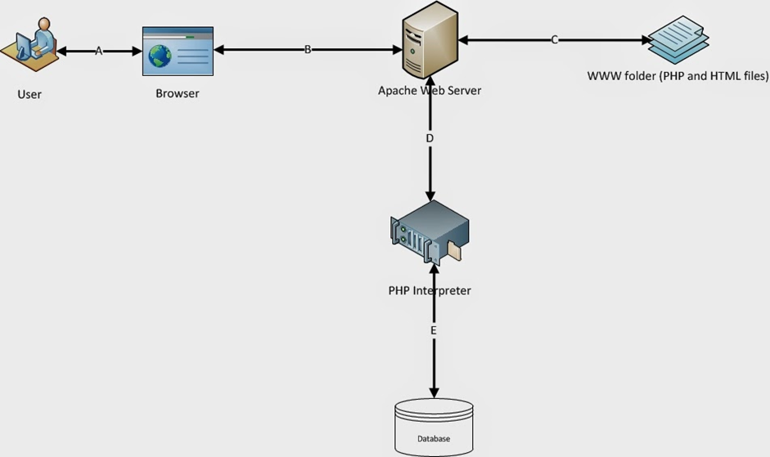

**Client/ Server Architecture, Project Architecture Description**

* **RESULTS AND DISCUSSIONS:**
* **User Panel:**

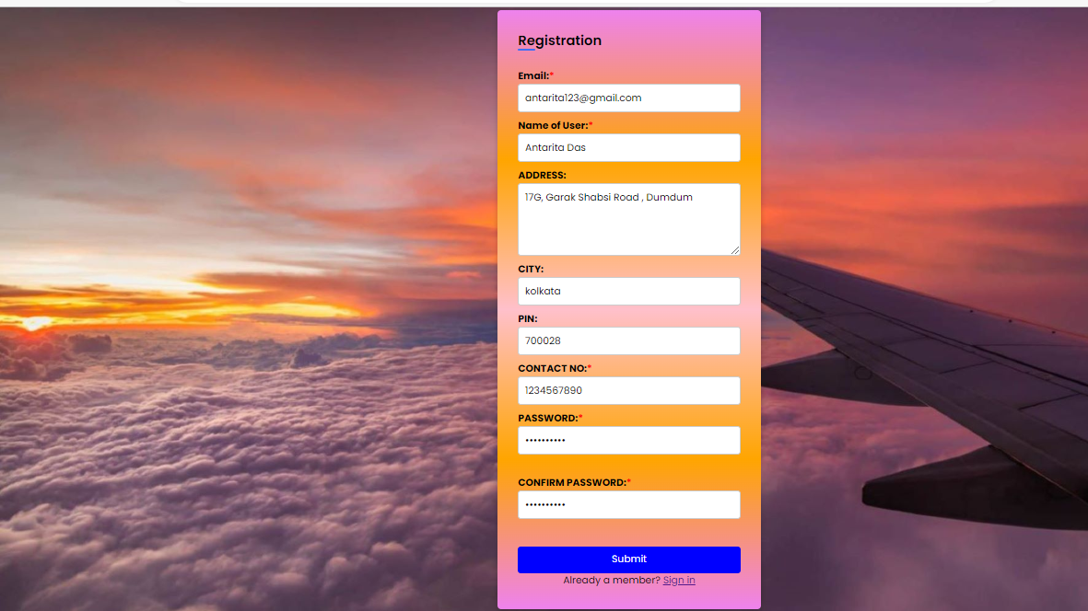**Registration page for new users:**

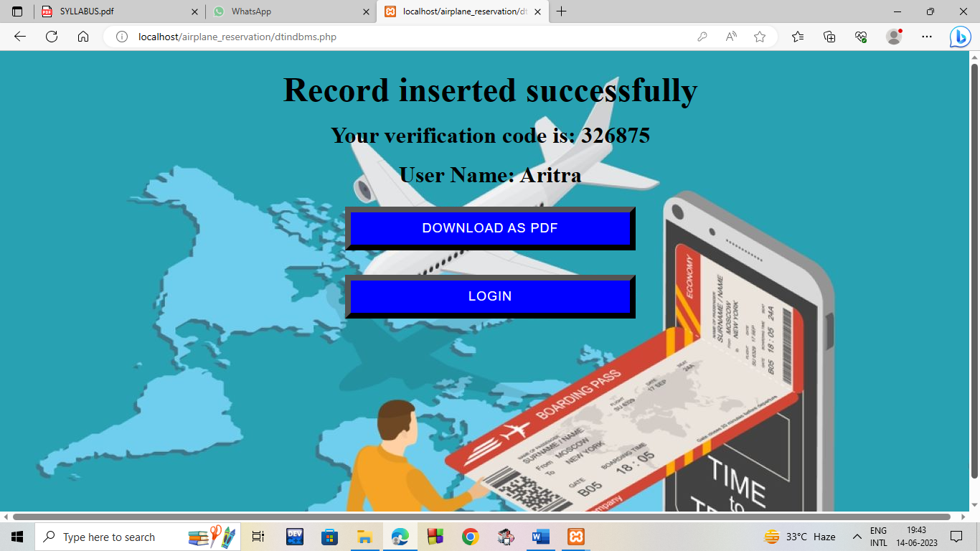**Registration done successfully with verification code generated:**

**Login Page for User:**

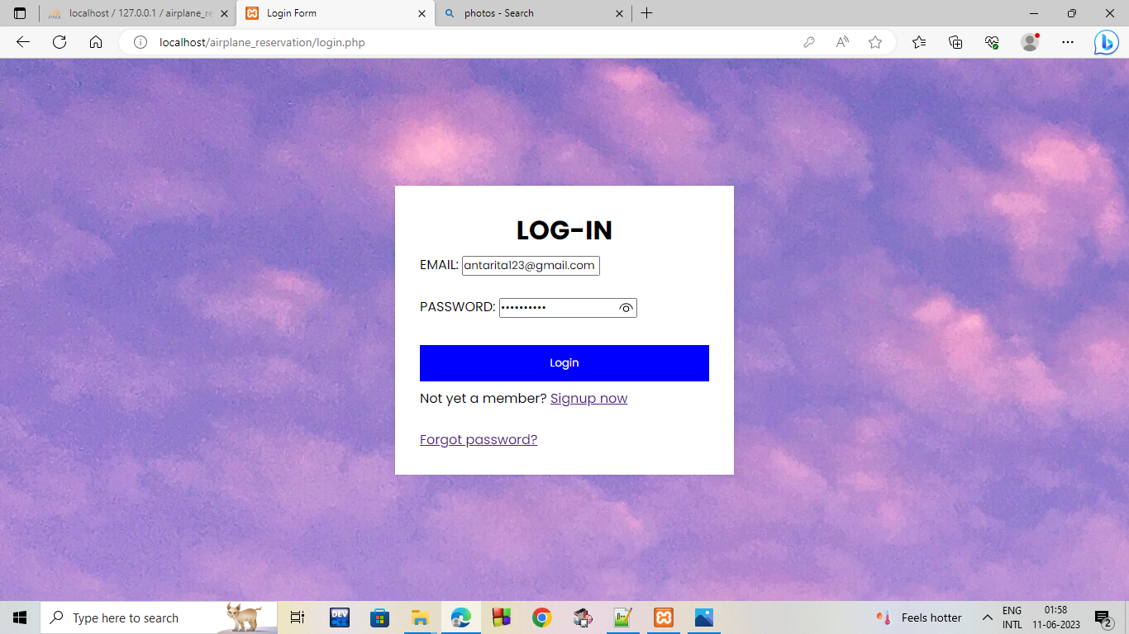

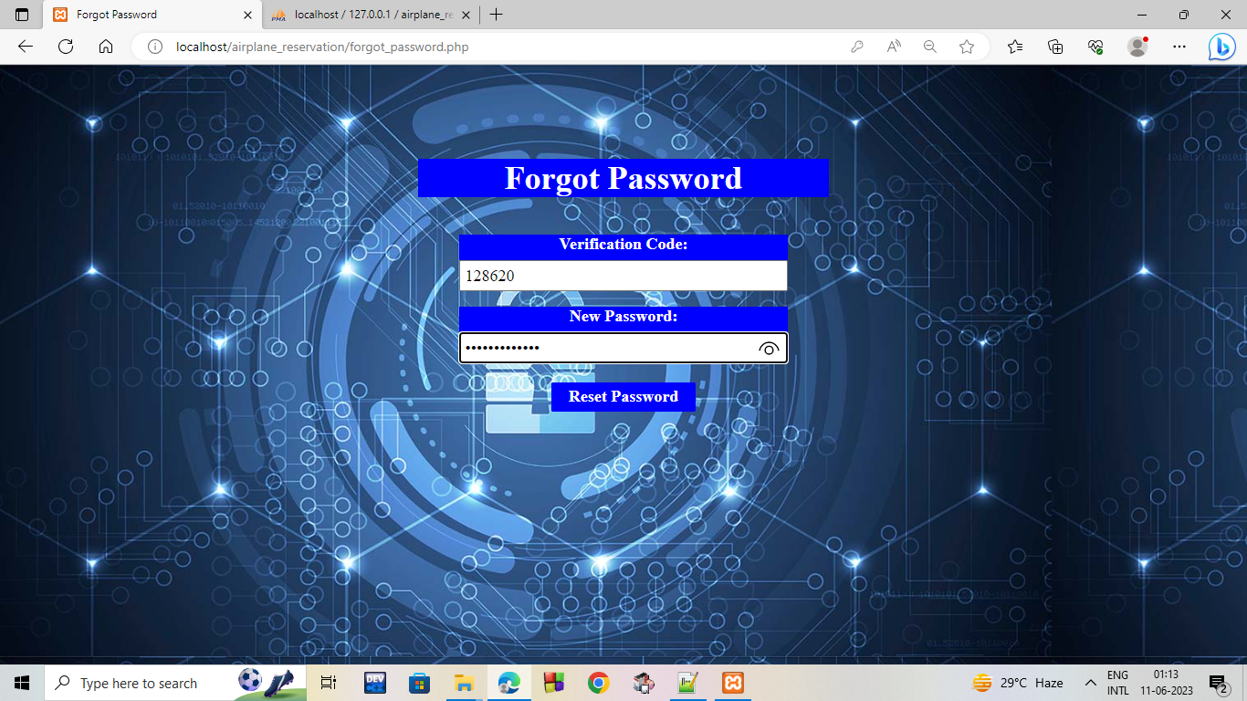**Reset Password Page:**

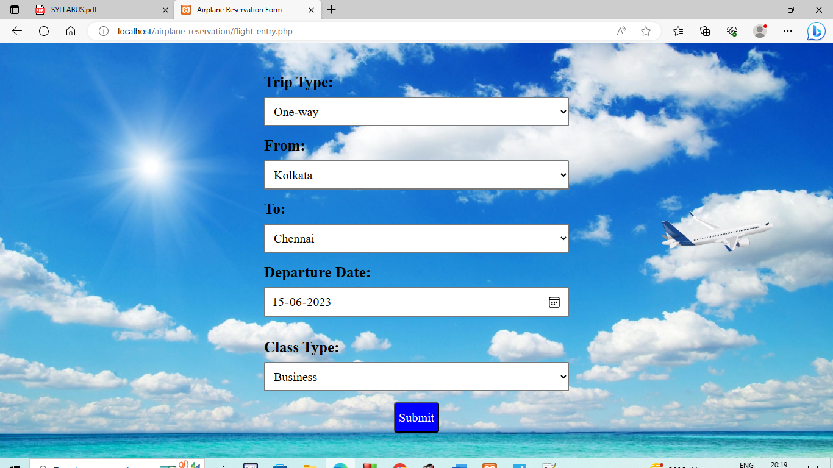**Flight Booking Page:**

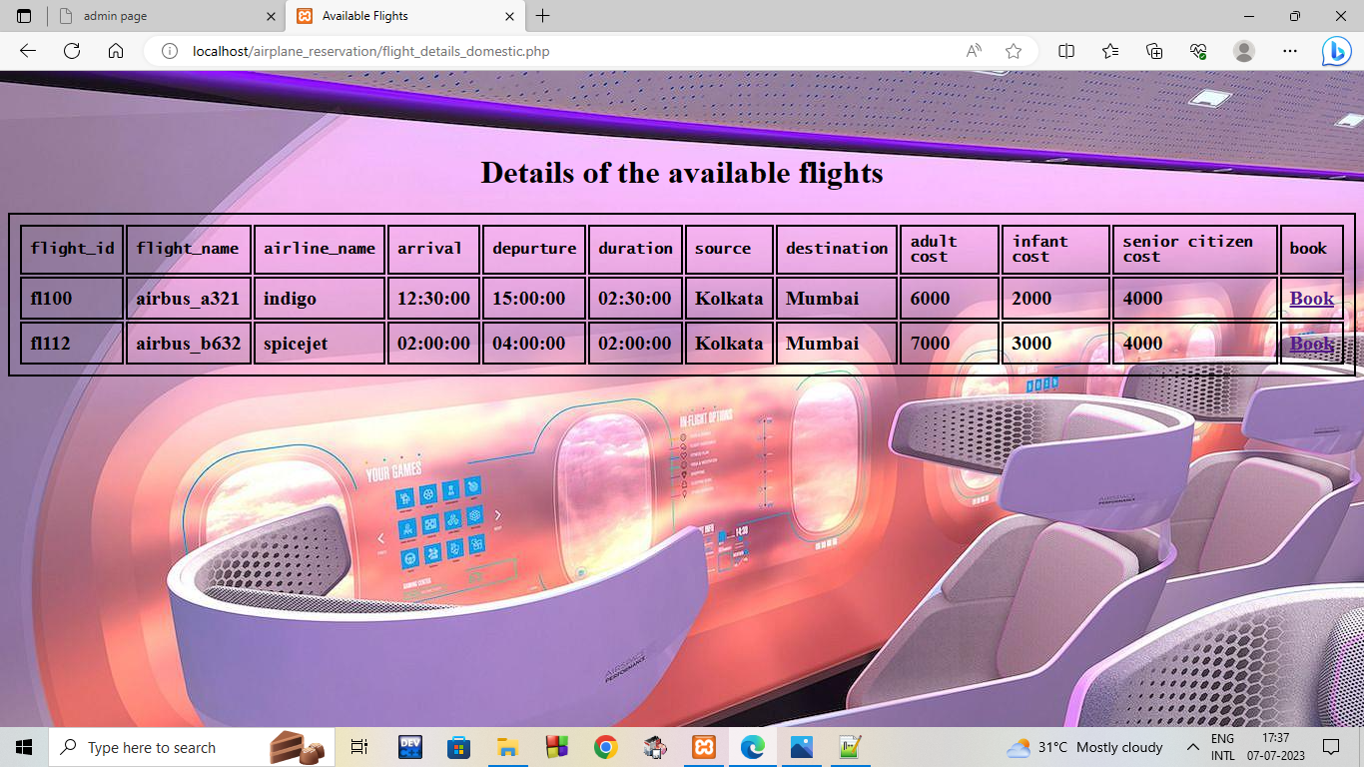**Flight Details Page:**

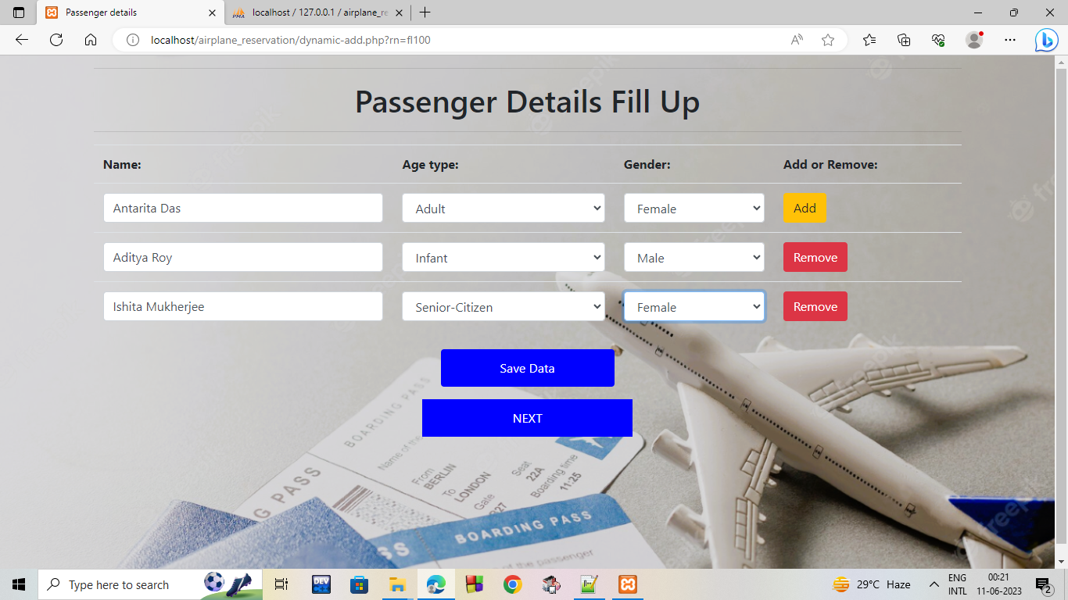**Passenger Details Page:**

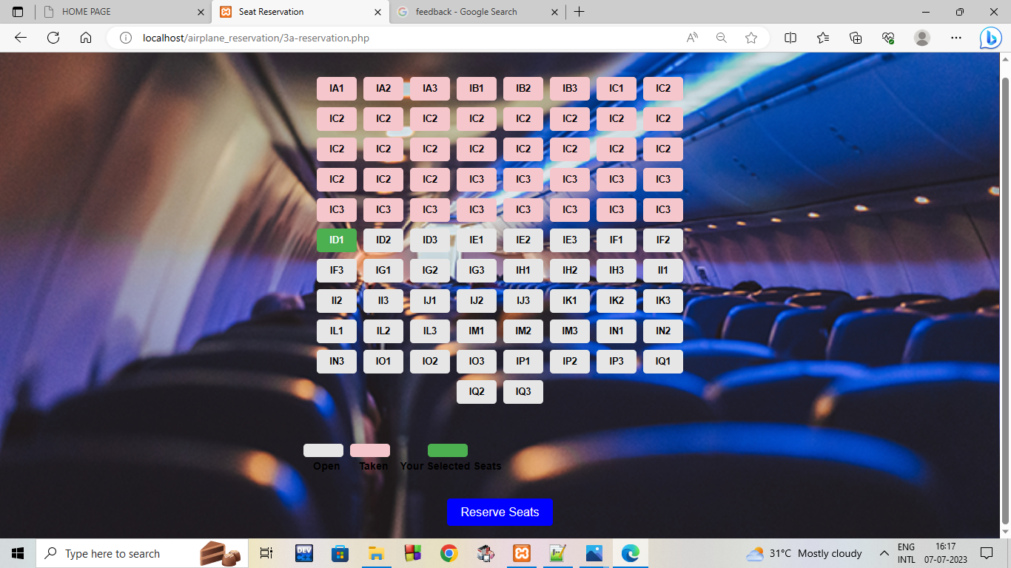 **Seat Selection Page:**

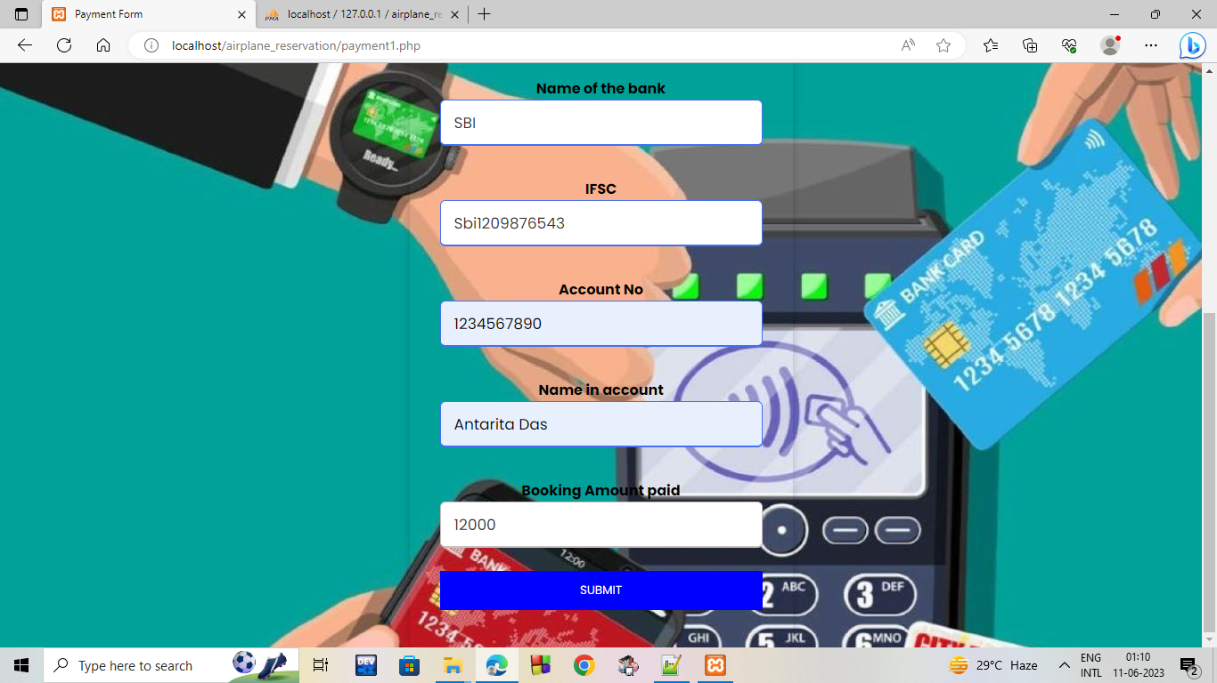**Payment Details Page:**

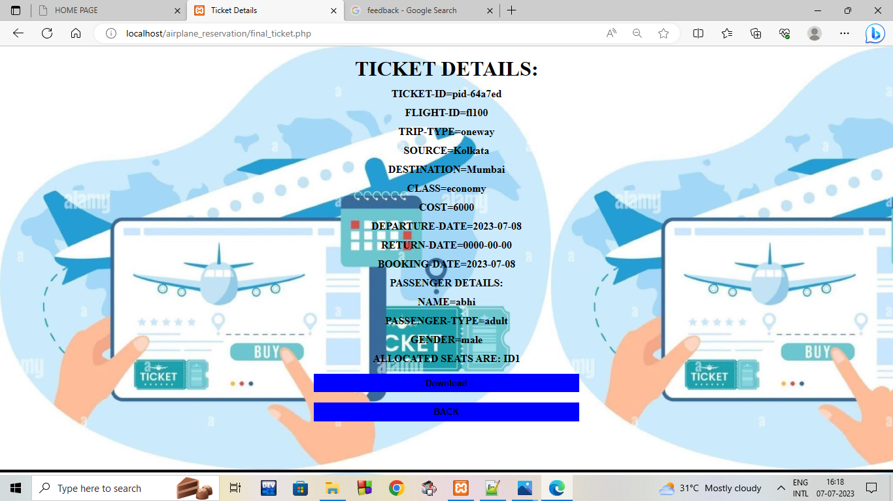**Ticket Details Page:**

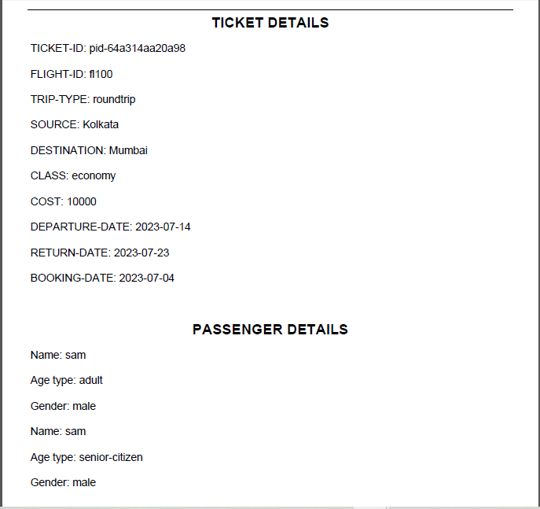**Downloaded Ticket Page :**

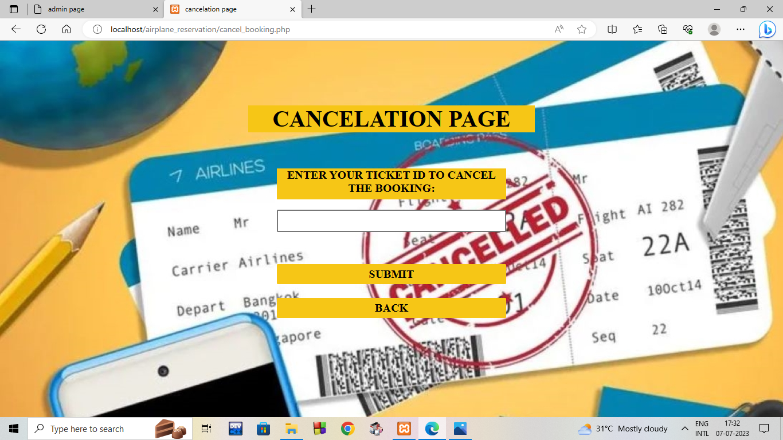**Cancellation Page:**

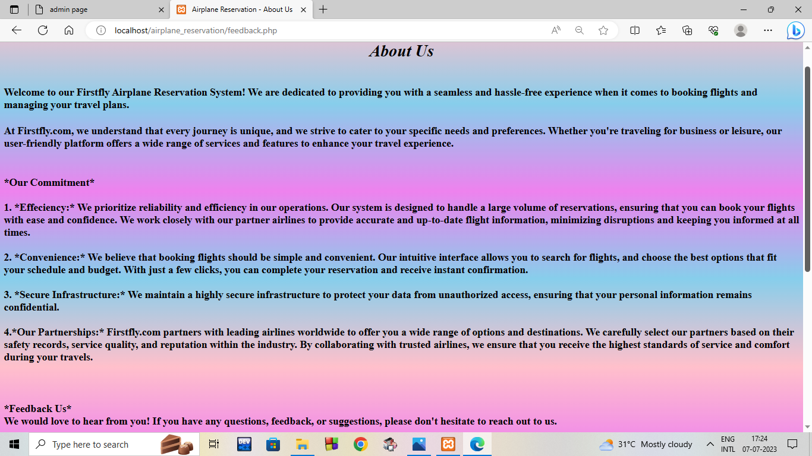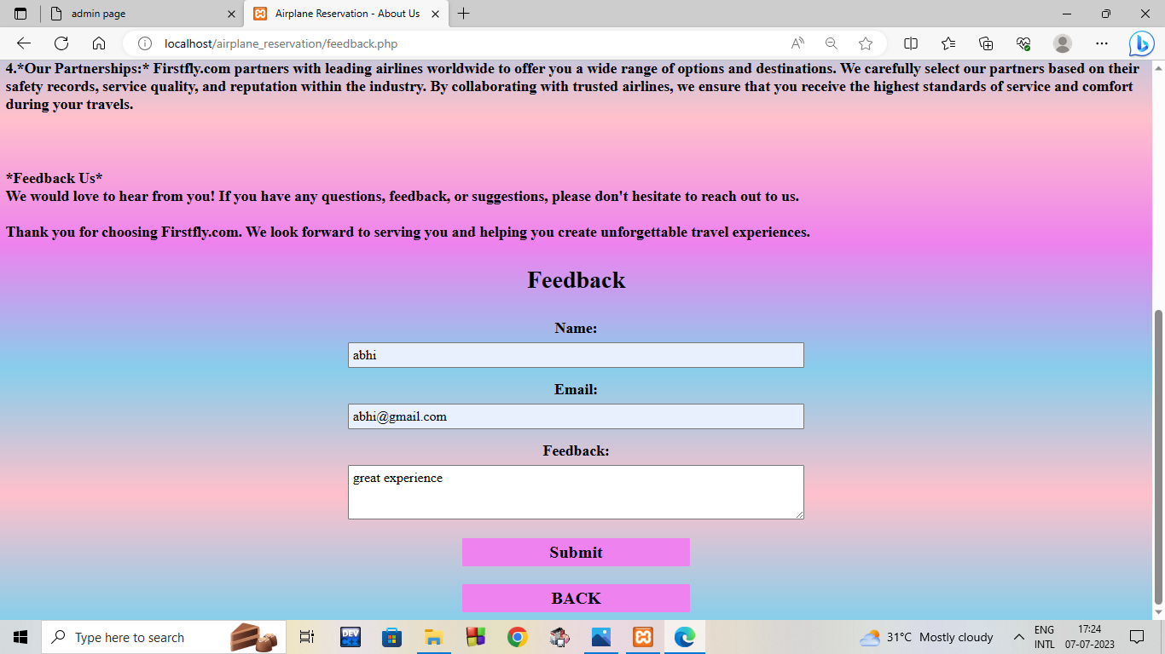**About Us and Feedback Page:**

* **Admin Panel:**

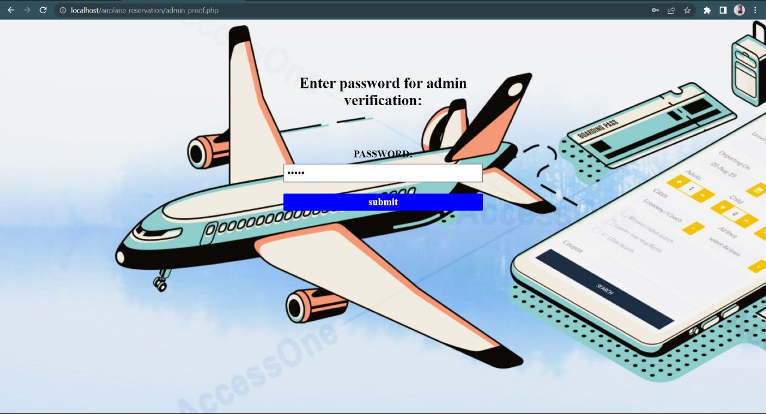**Login Page for Admin:**

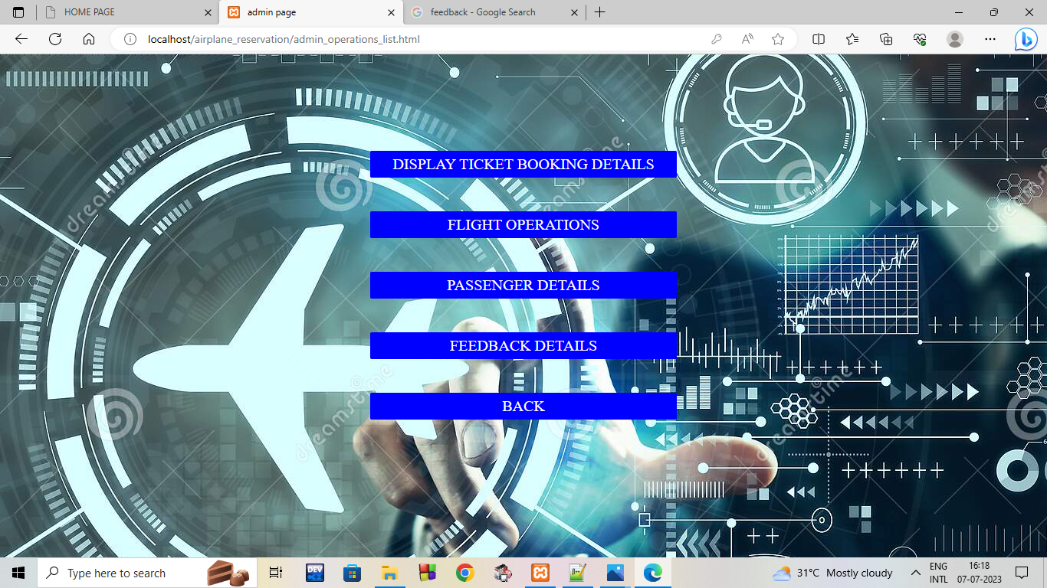**Operations performed by Admin Page:**

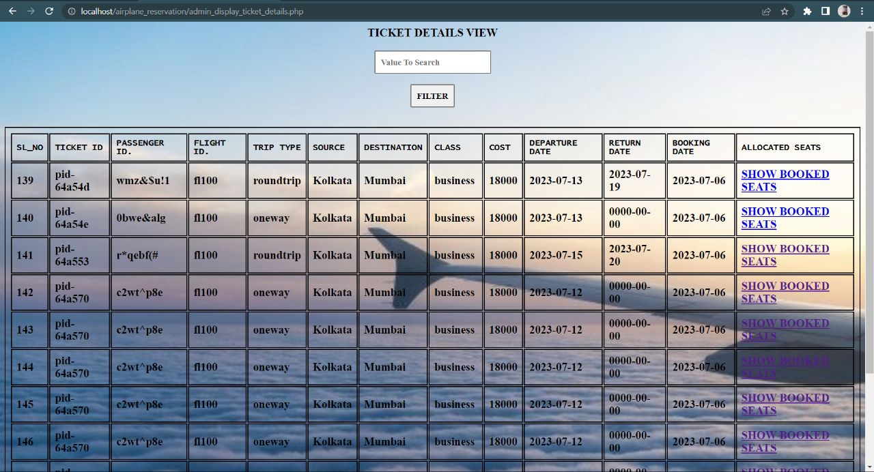**Display Ticket Details Page:**

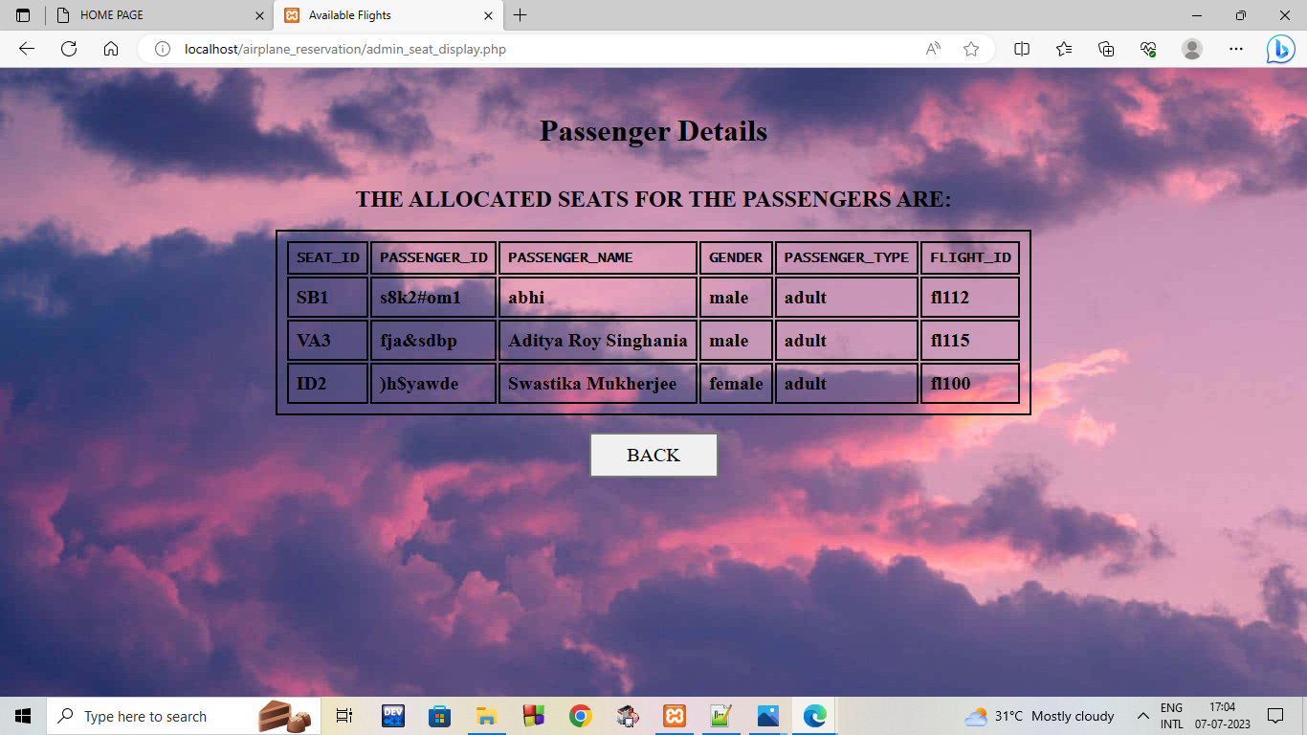**Display Passenger Details Page:**

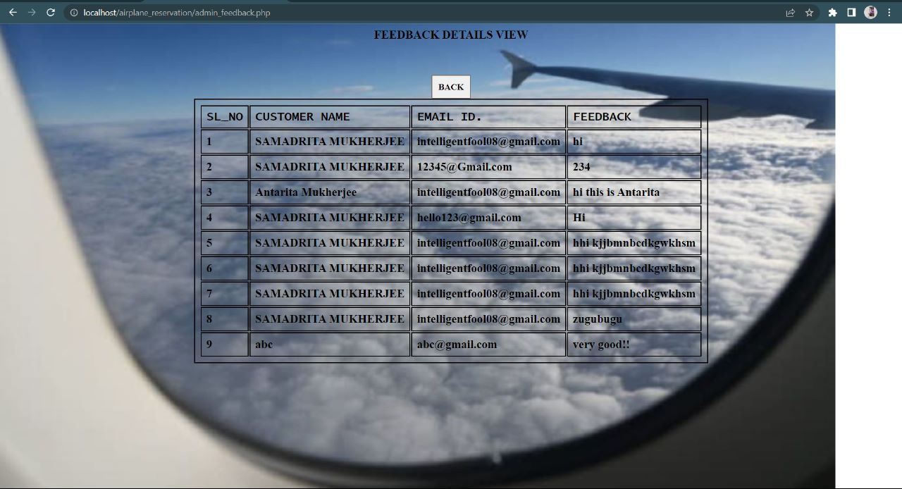**Display Feedback Received Page:**

**Update and Delete Flights Page:**

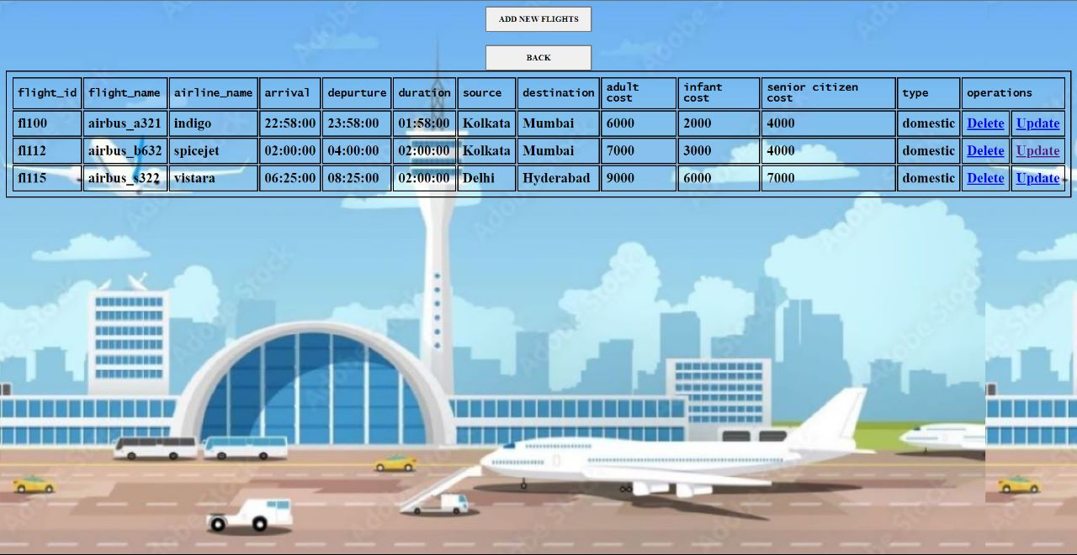

**Update Scheduled Flights Page:**

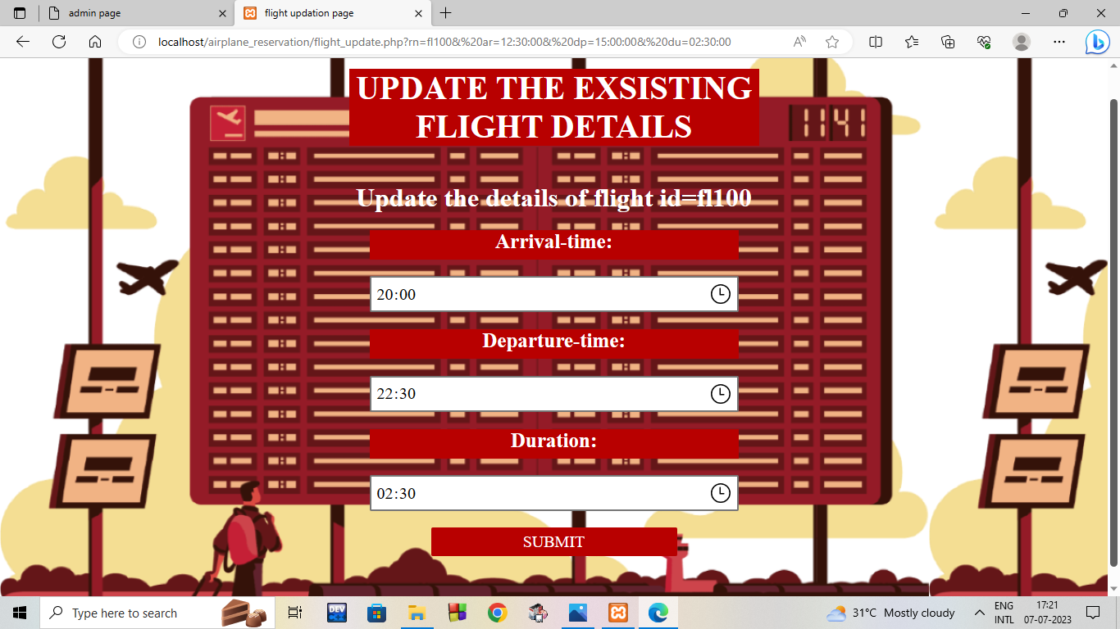

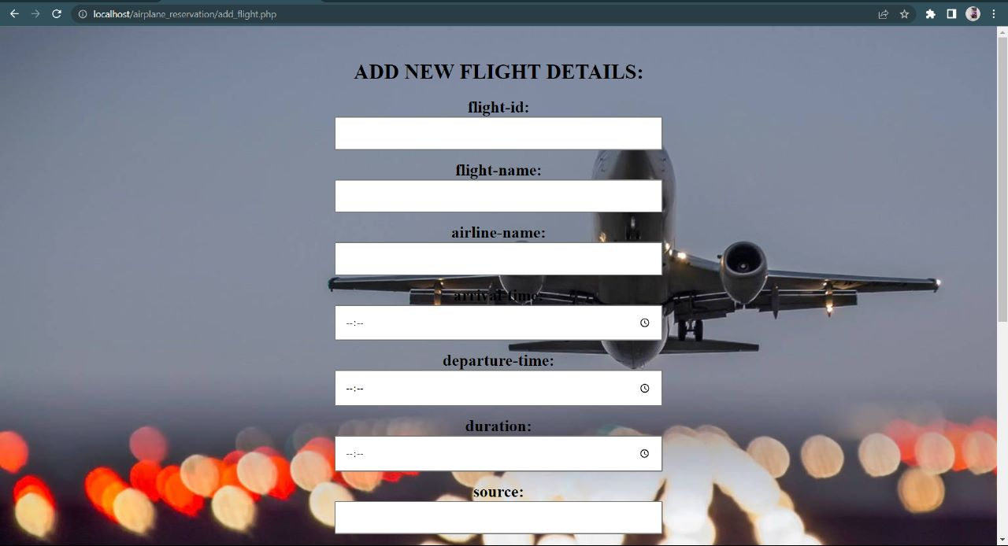**Add Flights Page:**

* **FUTURE SCOPE:**

**There are a few details that we were unable to implement due to time constrains and will be grouping them under the future scope:**

* + - 1. Price or selection according to class or seat is not done yet.
      2. The payment is dummy, so no refund policy is done here.
      3. There is no provision for food and luggage.
      4. The provision for boarding pass is not presented yet.
      5. Documents verification, captcha is not present in our project.
* **REFERENCES:**

1. <https://www.tutorialspoint.com/php/index.htm>
2. <https://www.w3schools.com/php/>
3. <https://www.w3schools.com/howto/howto_js_password_validation.asp>
4. <https://www.plus2net.com/php_tutorial/pdf-cell.php>
5. <https://www.codexworld.com/send-email-with-attachment-php/>
6. <https://www.onlyxcodes.com/2021/04/otp-verification-in-php.html>
7. <https://www.w3schools.com/css/css_syntax.ASP>
8. An Integrated Approach to Software Engineering – Pankaj Jalote
9. Fundamentals of Software Engineering – Rajib Mal

* **CONCLUSION:**

Given the hectic living style of the growing communities, everyone wants easy access to far off places. Air travel has made such accommodation easier. “Firstfly Airplane Reservation System” is built in the most basic way possible so that customers can understand. Booking and cancellation of the flights can be done very easily. All the important data of the customers are handled very securely and one can check the booking status just by logging in. The registration is a one-time process and customers can use the same login details even if they want to book flights through our portal after a considerable amount of time. With the growing demand in airway travel, “Firstfly Airplane Reservation System” brings forward the most handy and easy way to book a flight.

(Signature of Supervisor) (Signature of external examiner)